**EXPERIMENT NO:-3**

* **AIM:** TO STUDY AND TEST NAND & NOR GATE AS A UNIVERSAL GATE.

* **APPARATUS:** Bread Board, Connecting wires, LEDs, Resistor

IC’s (1) 74LS00 (Quad two I/P NAND gate)

(2) 74LS02 (Quad two I/P NOR gate)

* **THEORY:**

We know that AND, OR and NOT gates are the basic building blocks of digital computer. They are called the basic gates. Any digital circuit of any complexity can be build using only these three gates. A universal gate is a gate, which alone can be used to build any logic circuit. So to show that the NAND gate and the NOR gate are universal gates. We have to show that the all three basic gates can be realized using only NAND gates or using only NOR gates.

As AOI gates can be implemented by using NAND & NOR gates as shown in circuit diagram, NAND & NOR gates are called as universal gates.

There are number of logic families. The logic gates so far and many other logic circuits are available in one of those logic families. Each logic family has its own merits and demerits.

TTL (Transistor- Transistor-Logic) is most popular of logic families. TTL or TTL family is named because of its dependence on transistor alone to perform basic logic operation. It is most widely used bipolar digital IC family. The TTL uses transistors operating in saturated logic families. The basic TTL logic circuit is NAND gate. Good speed, low manufacturing cost, wide range of circuit availability is SSI and MSI are its merits.

* **THEORY:**
* [A] NAND GATE as UNIVERSAL GATE:

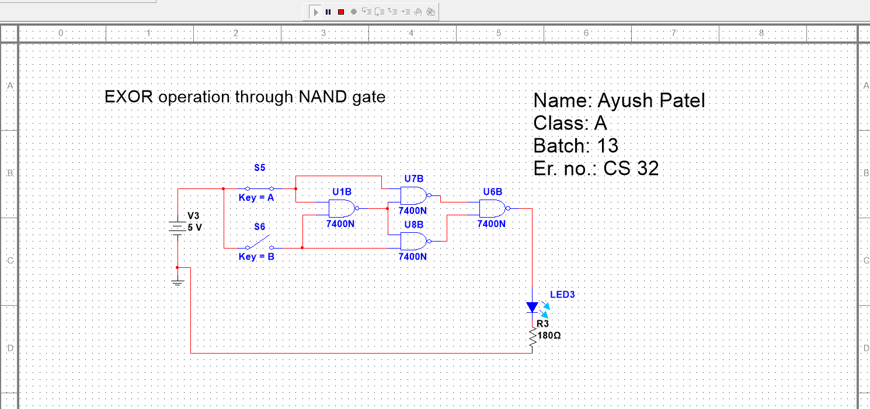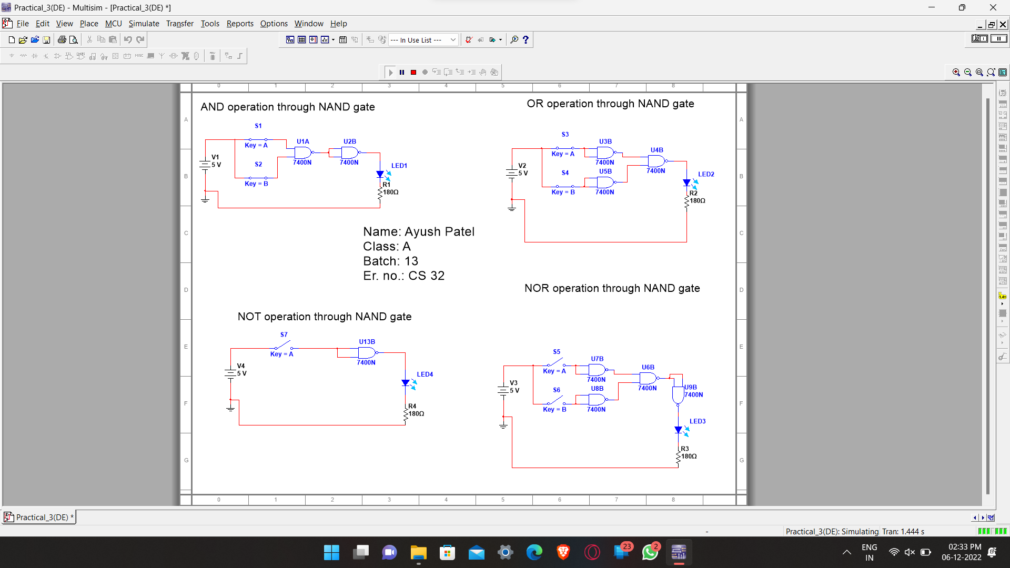

Pin configuration of the 74LS00 NAND gate IC:

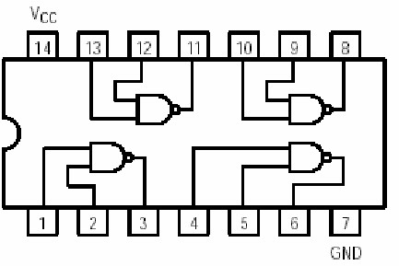

TRUTH TABLE

|  |  |  |  |  |  |  |  |  |  |  |  |  |  |  |  |  |  |  |  |  |  |  |
| --- | --- | --- | --- | --- | --- | --- | --- | --- | --- | --- | --- | --- | --- | --- | --- | --- | --- | --- | --- | --- | --- | --- |
| |  | | --- | | Draw figure of NAND Gate here | | |  |  |  |  | | --- | --- | --- | --- | | **A** | **B** | **OUTPUT** | **Output voltage level** | | 0 | 0 | 1 | 2.11 | | 0 | 1 | 1 | 2.11 | | 1 | 0 | 1 | 2.11 | | 1 | 1 | 0 | 2.11 | |

* [B] NOR GATE as UNIVERSAL GATE :

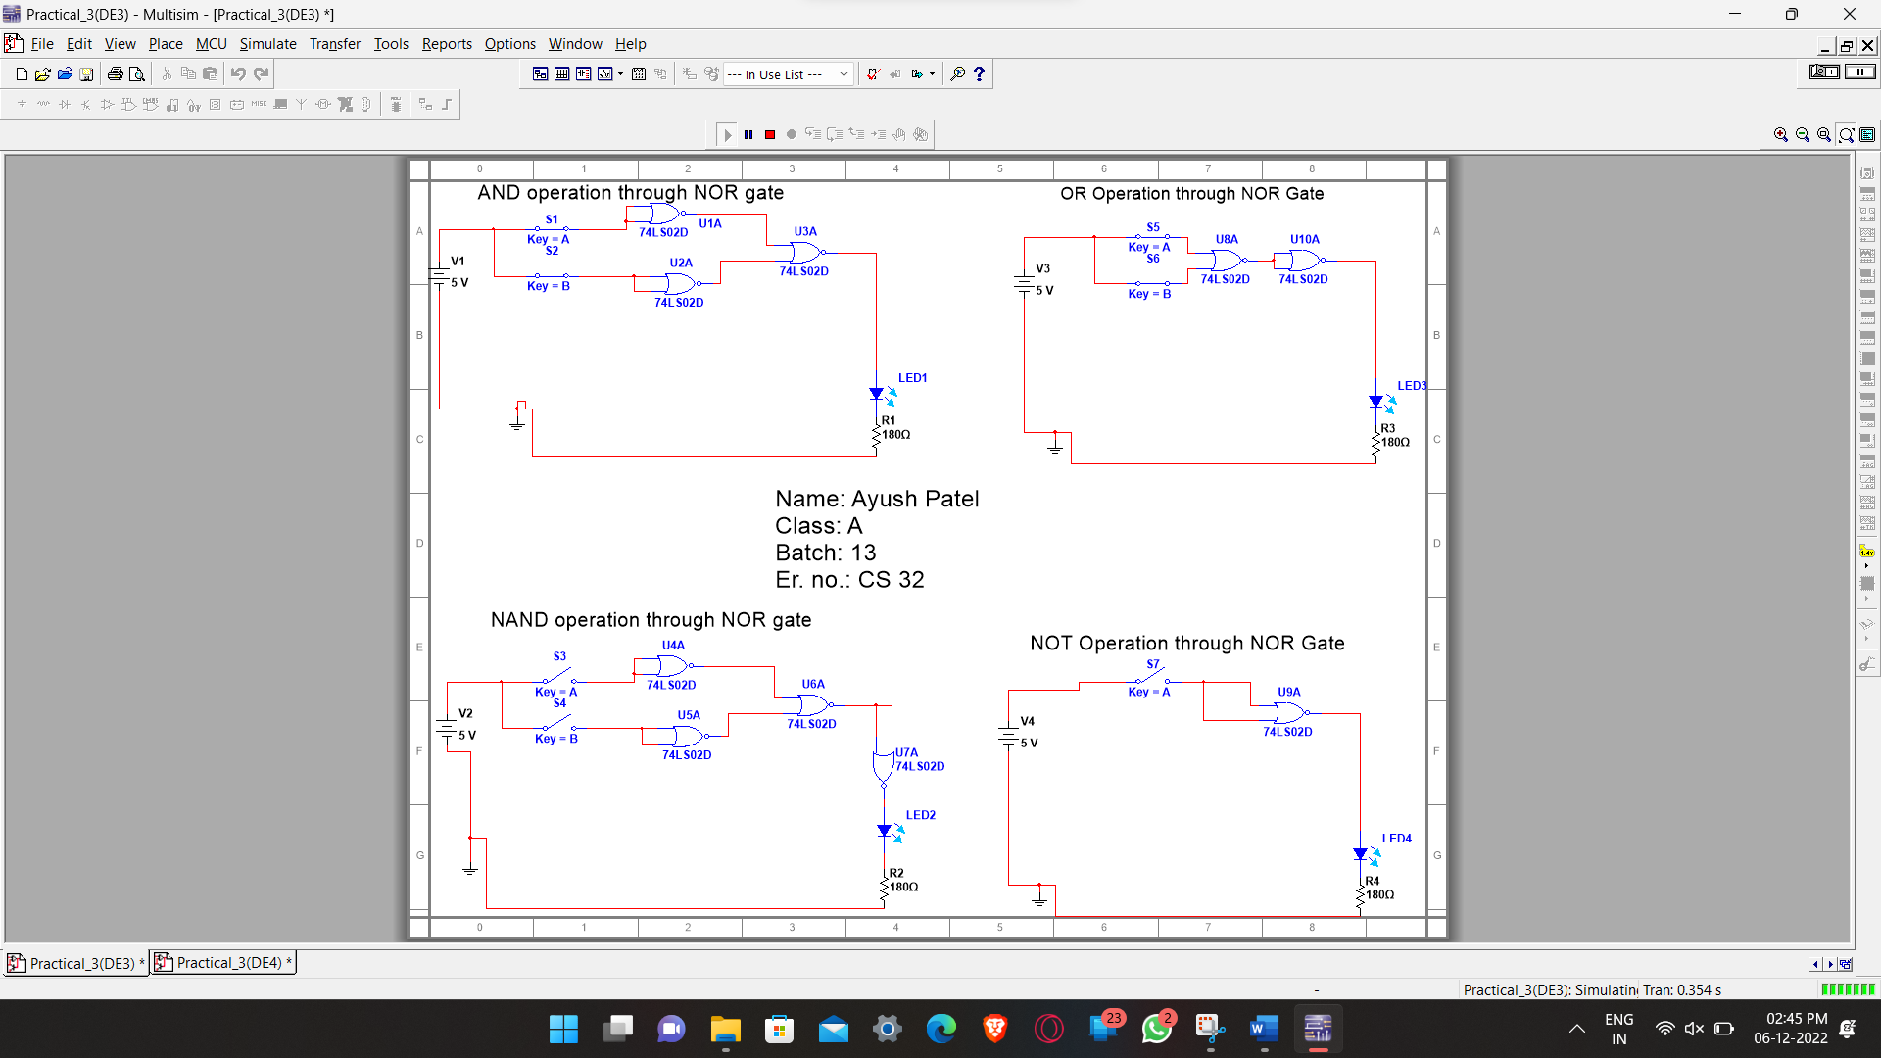

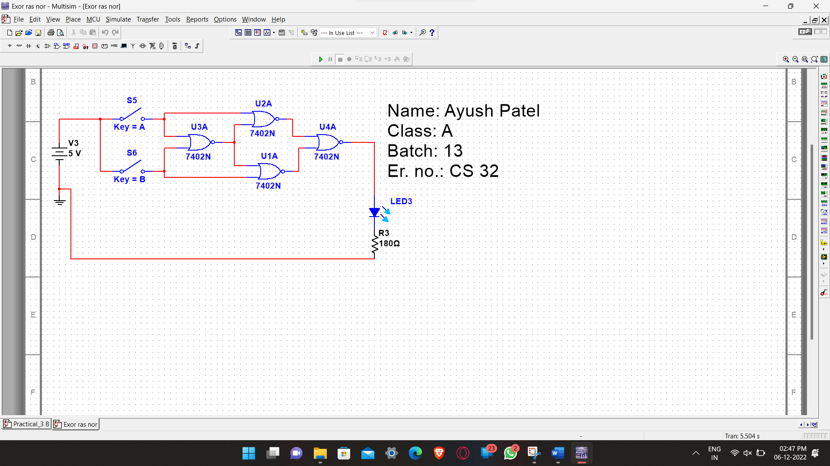

**Pin configuration of the 74LS02 NOR gate IC:**

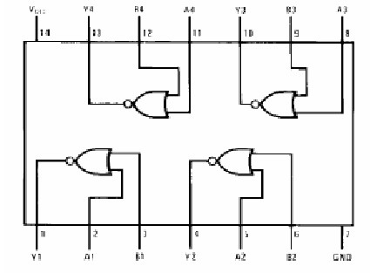

TRUTH TABLE

|  |  |  |  |  |  |  |  |  |  |  |  |  |  |  |  |  |  |  |  |  |  |  |
| --- | --- | --- | --- | --- | --- | --- | --- | --- | --- | --- | --- | --- | --- | --- | --- | --- | --- | --- | --- | --- | --- | --- |
| |  | | --- | | Draw figure of NOR Gate here | | |  |  |  |  | | --- | --- | --- | --- | | **A** | **B** | **OUTPUT** | **Output voltage level** | | 0 | 0 | 1 | 2.11 | | 0 | 1 | 0 | 2.11 | | 1 | 0 | 0 | 2.11 | | 1 | 1 | 0 | 2.11 | |

* **PROCEDURE:**
  1. Install ICS 7400 & 7402 on the bread board.
  2. Connect pin number 7 & 14 of all ICS to ground & +5v supply respectively.
  3. Make the connection as shown in the logic diagram for AND, OR, NOT, and EXOR gate using NAND gate only.
  4. Verify the truth tables of AND, OR, NOT and EX-OR gate.
* **CONCLUSION:**

In this practical we have performed and verify the NAND and NOR gate as an universal gate.